**Assessing the Influence of Different Types of Probing on Adversarial Decision-Making in a Deception Game**

| Md Abu Sayed, Mohammad Ariful Islam Khan, Bryant A Allsup, Joshua Zamora |
| --- |

Department of Computer Science, University of Texas at El Paso

{msayed, mkhan16, }@miners.utep.edu

**Abstract**

Understanding human decision making when prompted with choices of various costs is essential in many areas such as in cyber security. In this paper we will use a deception game (DG) to examine different costs of probing on adversarial decisions. To achieve this we utilized an IBLT model and a delayed feedback mechanism to mimic knowledge of human actions. Our results were taken from an even split of deception and no deception to compare each influence. It was concluded that probing was slightly taken less as the cost of probing increased. The proportion of attacks stayed relatively the same as the cost of probing increased. Although a constant cost led to a slight decrease in attacks. Overall, our results concluded that the different probing costs do not have impact on the proportion of attacks whereas it had a slight noticeable impact on the proportion of probing.

**I. Introduction**

Cyber attacks are increasing exponentially day by day as the digital space becomes more prevalent. These attacks involve unwelcome attempts to steal, expose, alter, disable or destroy information through unauthorized access to computer systems. Current solutions to combat these cyber attacks have proven somewhat sufficient such as intrusion detection systems (IDSs) and filtering strategies. Intrusion detection systems operate by searching for traces of known attacks or deviations from normal activity whereas filtering strategies filter out activities that may be seen as malicious. Although, the need for increasingly dependable infrustructures to combat these attacks are in demand now more than ever. Thus, the use of deception has proven advantageous as an attempt to combat these attacks. Deception involves providing false information in order to deceive a person into believing said false information. Deception is used in cyber security as a technique where honeypots act as decoys to prevent actual web servers from being attacked.

There have been various methods to help understand the human nature of these attacks which have been by the use of Instance Based Learning (IBL). This model will be used since it may provide insight into human decision making in adverse scenarios involving cyber attacks.

Furthermore, probing is an under utilized factor that must be considered. For instance, when adversaries make a decision on which server to attack they often probe before making an attack which will provide information about the server beforehand. To realize the effect of adversary decisions, the cost of these probing actions is the primary focus of this paper.

We developed a deception game to understand the effect of these probing actions. We believe that understanding these probing action costs will provide insight into adversary actions and as a result this will help better predict and combat cyber attacks.

The rest of this paper is organized as follows. Section II discusses the task description. Section III describes methodology, and section IV discusses result. Finally, conclusions are presented in Section V.

**II. TASK DESCRIPTION**

The deception game(DG) is a single user multi-choice game where the goal is to figure out the correct server to attack. In this game Users are tasked with attacking one real server when presented with four servers, two real and two fake(honeypots), over the course of 30 rounds and at the end of each round users will be given feedback(Delayed Feedback). Users are given signals by the system to tell users if they are honeypots or if they are real. Through 15 of these thirty rounds the server will lie about what is being signaled.

When the game begins users will take the role of the attacker and the system will play defender. The first thing that will happen in the game is the user will decide which server to probe for information, users can probe as many servers as they want. This is known as the probing stage and is where the signals will appear to notify the user if the attacker is attacking a honeypot or a real server. It will be up to the user to determine here if this is a deception round(user is lied to) or if this is the truth. Once the user chooses they will then enter the attack stage. Here users are looking at the one server they chose and are given two options, attack or retreat. If the user attacks, the round will be over and the delayed feed-back will be given telling the user if they won or lost points for the round. If the user retreats the round will be over and the results will not go for or against the user. (need to know if the feedback is given, revealing if it was a honey pot or not). Once the 30 rounds are done with all the participants we will use the results to calculate the score.

The score is calculated with three different metrics in mind. There is the no cost, set cost and incremental cost. A baseline metric that is true across all the metrics will be attacking a correct server will give you 10 points, attacking a honeypot will lose you 10 points and not attacking will give 0 points. The first metric we will use is the no cost metric. The no cost will be the baseline and will only calculate points based on decisions made in the attacking stage. The next metric is set cost. In the set cost metric users are given points based on if they probed the correct server, so if a user probes a server and it ends up being a honeypot then the user will be given -5 points and if the user probes a server and it is a real server the user is given +5 points. This info is still withheld until the delayed feedback is given as the score is based on the servers actual property and not the one that is shown. The final scoring system is the incremental. The incremental will resemble the set cost with the difference being instead of +5 or -5 points when probing a server the scoring is changed to 5(number of real servers probed prior) and -5*h(number of honeypot servers that you probed prior).

| Deception Cost | | | |
| --- | --- | --- | --- |
|  | No Cost: | Set Cost | Incremental Cost: |
| Real | 0 | 5 | 5 |
| Honeypot | 0 | -5 | -5*h |
| No Probing | 0 | 0 | 0 |

| Attacking Cost | | | |
| --- | --- | --- | --- |
|  | No Cost: | Set Cost | Incremental Cost: |
| Real | 10 | 10 | 10 |
| Honeypot | -10 | -10 | -10 |

In this experiment we will be using the IBLT Model to replicate human experience found in **“Influence of probing action costs on adversarial decision-making in a deception game published in Lecture Notes in Networks and Systems”[1]** We decided to use the iblt model as we were familiar with it and it allows us to replicate results to found in the paper [1]. In order to replicate these results our team also implemented items such as delayed feedback.

Delayed feedback is a method that gives a response to a user at the end of a round. The prior method is that as soon as a decision is made the feedback is given. The problem with this is that responses are made within the activity and allows for changes to be made when it happens, tampering with each instance of a problem. This would primarily be seen in the probing stage of the set and incremental point metrics where a user would receive or lose points in the probing stage. Since we changed to delayed feedback no additional information would be given that would help agents during each round. This allows us to better use the different points metric and capture a more accurate representation.

The different costs used in the deception game were used to replicate the study. This is the same for the number of trials given. The number of participants is an arbitrary number to get a wider look if the trends stayed consistent in the human experiment.

**III. METHODOLOGY**

1. **Experimental Design**

In our pyibl modling, initially we strat with 40 participant in no-cost probe, constant-cost probe, and increasing-cost probe and 30 trial for each participant. Each of these conditions had the same number of webservers, and the proportion of honeypot webservers in the network was constant across all the conditions (50%). We keep four webservers, out of the four webservers, 2 of them were honeypot webservers, while the other 2 were regular webservers. In no-cost condition, the player had no cost for their probe actions on honeypot webservers in the probe stage of DG. In constant-cost conditions, the honeypot webserver probe cost remained constant(5) with the repeated probe attempts on honeypots. In increasing cost conditions, the honeypot webserver probe's cost increased linearly(5*h, number of interaction with honeypot server) with the repeated probe attempts to honeypot servers. Around all the conditions, each of the rounds had a probe stage followed by the attack stage.

Each of the three conditions had 30 trials, out of which 15 of them were randomly assigned as deception rounds, while the rest of the rounds had no deception. Also, the deception and non-deception rounds in DG did not form a particular sequence or pattern, that’s why it’s to predict.

1. **Deception Game**

We are showing some screenshots of our developed deception game model only for increasing cost. Figure1 demonstrates the initial interface in a particular round form where player can probe any webserver and then go to attack stage or dirrectly go to the attack stage . Response(signal, not outcome) received after selecting a particular webserver has shown in figure2. Figure3 depicts how attack attack looks like which is more or less like probe stage. Finally, figure4 showed one full round of increasing cose condition.

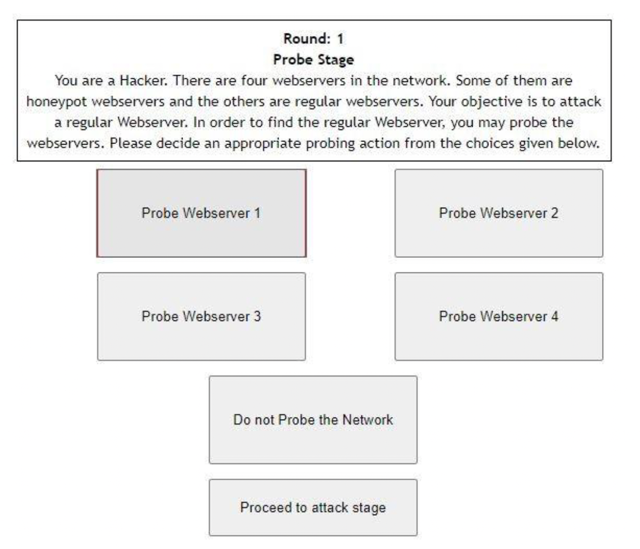



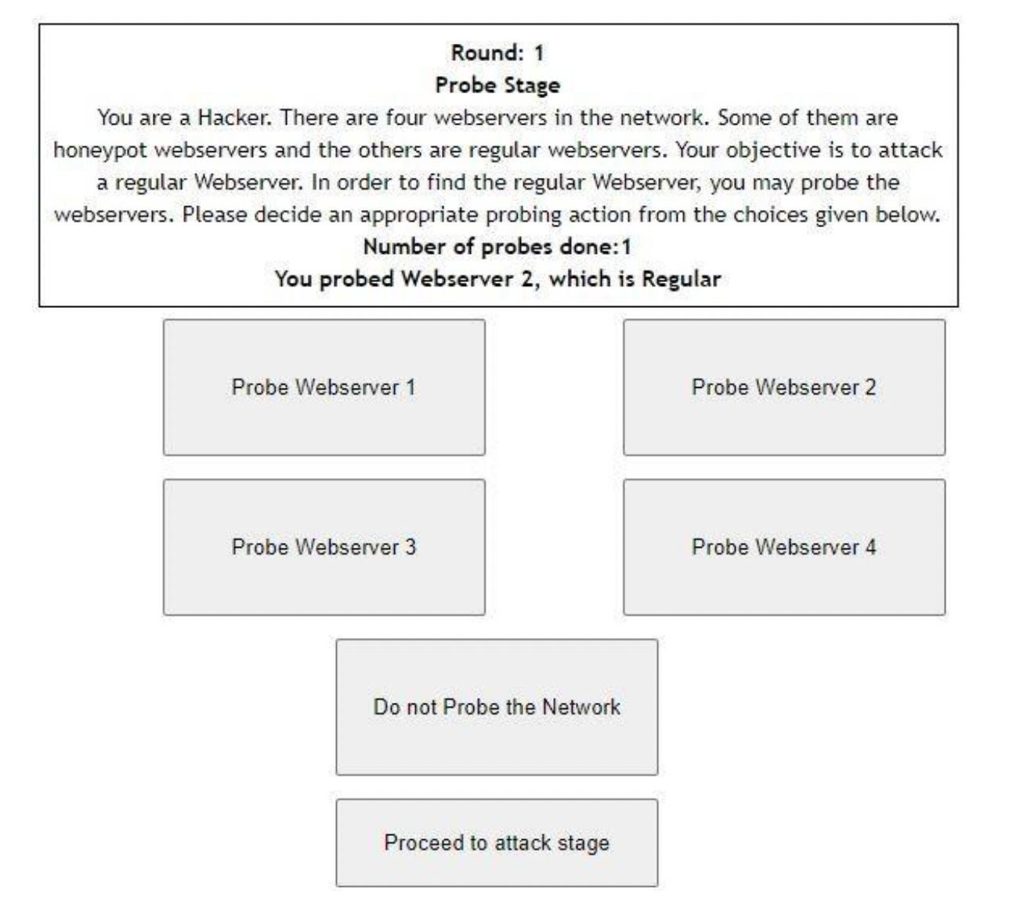



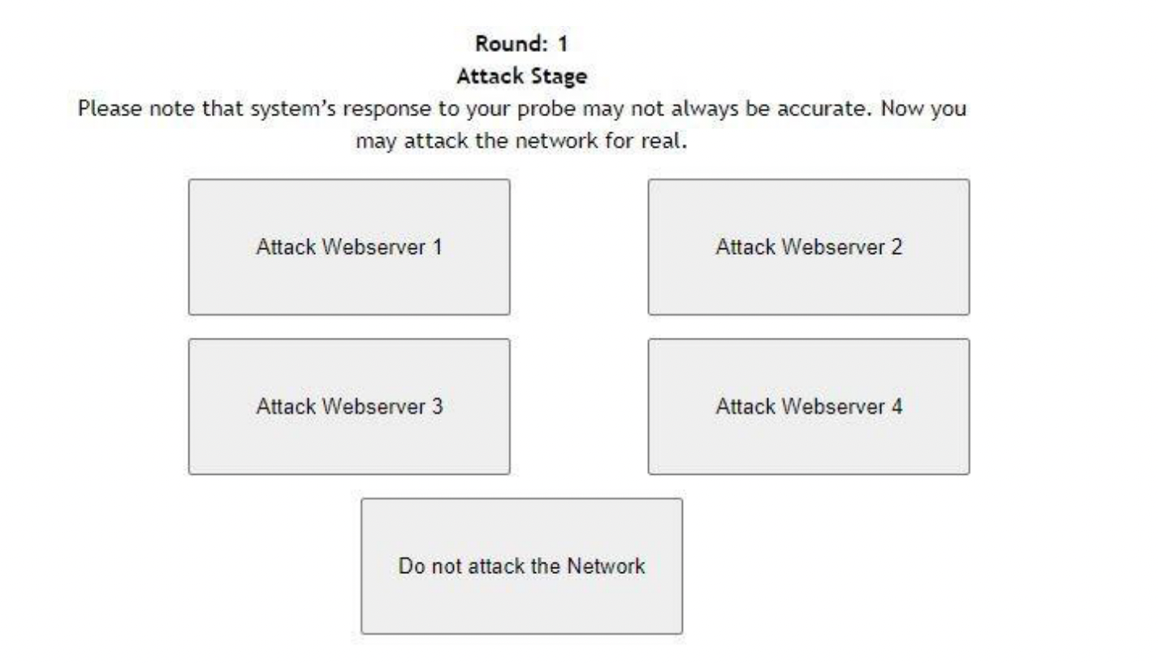



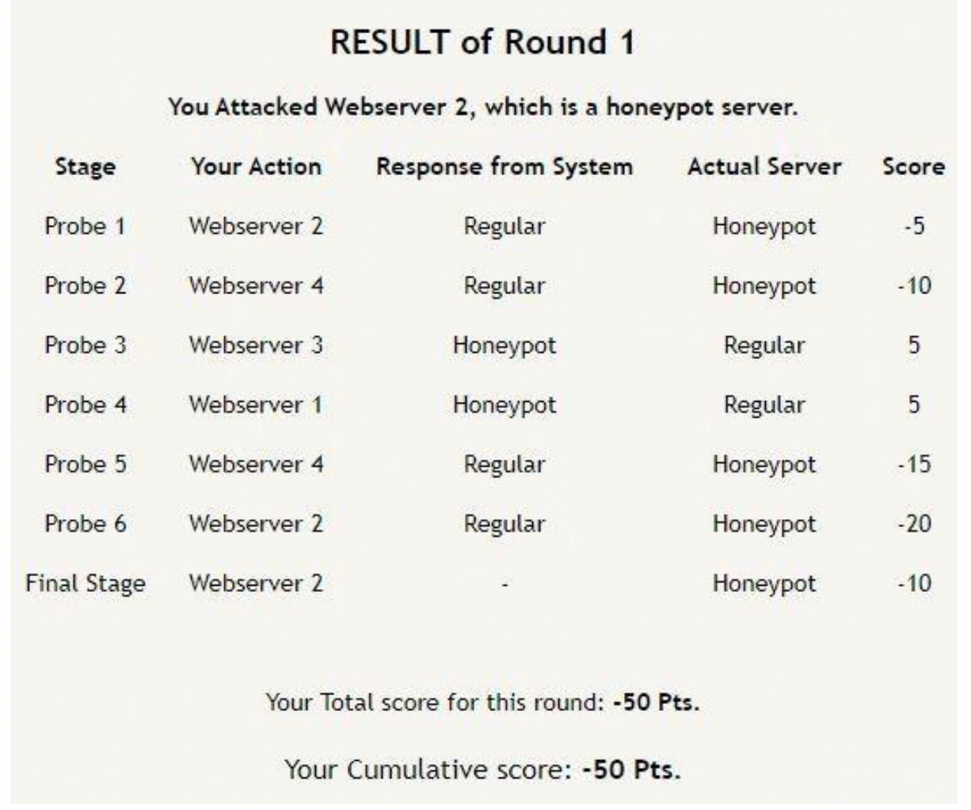



**IV. RESULTS**

1. **Influence of different cost conditions over the trials on adversarial decisions during probe stage**

We observe the effect of different cost condition on adversarial decision making in probe stage. We saw probing percentage on regular webserver is almost same over three cost condition(0.42, 0.40, 0.40) . Probing percentage on honeypot webserver also followed the same pattern(0.42, 0.41, 0.40). Interestingly, no probing percentage slightly increase(0.16, 0.18, 0.20) over the three cost conditions (no cost, constant cost, increasing cost) . The main reason behind that when cost increases, agent will choose no probe because of no associated cost. The percentage data of probe on regular, honeypot webserver, we collect from our pyibl modeling. Overall, form figure, we see different probling cost conditions over the trial do not have any impact on the adversarial decision making at probe stage.

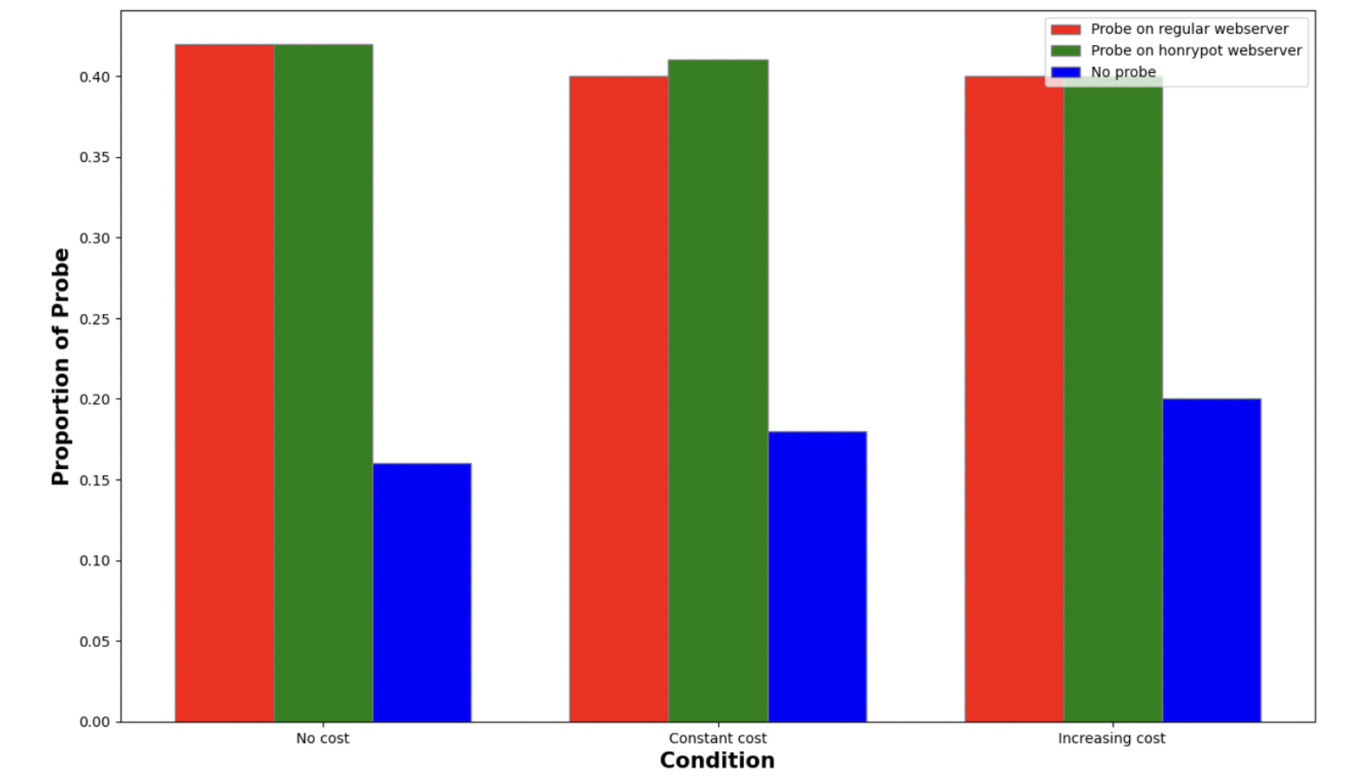



1. **Influence of different cost conditions over the trials on adversarial decisions during attack stage**

In every trial, attack decision takes place only once, whereas probing stage happens at most 5 times. We also observe the effect of different cost condition on adversarial decision making in attack stage. Attack percentage on regular webserver is almost same over three cost condition(0.39, 0.38, 0.36) . Percentage of attack on honeypot webserver also followed the same pattern (0.40, 0.39, 0.38).

Interestingly, no attack percentage slightly increase(0.20, 0.22, 0.26) over the three cost conditions (no cost, constant cost, increasing cost). The percentage data of attack on regular, honeypot webserver, we collect from our pyibl modeling. Overall, form figure, we see different probling cost conditions over the trial do not have any impact on the adversarial decision making at attack stage. Interestingly, when we set prepopulation value to a small value, we do not see specific pattern, then we slightly increase the prepopulation and see the pattern.

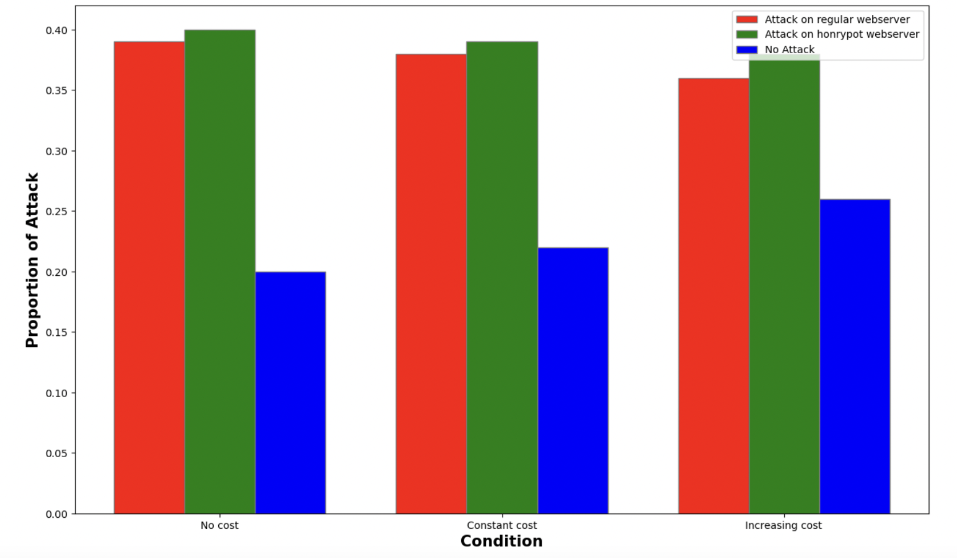



1. **Analysis of human data**

We also collected human data from work [1] we trying to replicating. Figure 7 and 8 shows proportion of probe and attack on different cost conditions. Interestingly in human data, no probe never happened. In figure 7, we see probability of probe stays almost same on different cost conditions. In figure8, we see probability of attack also same accross different cost conditions.

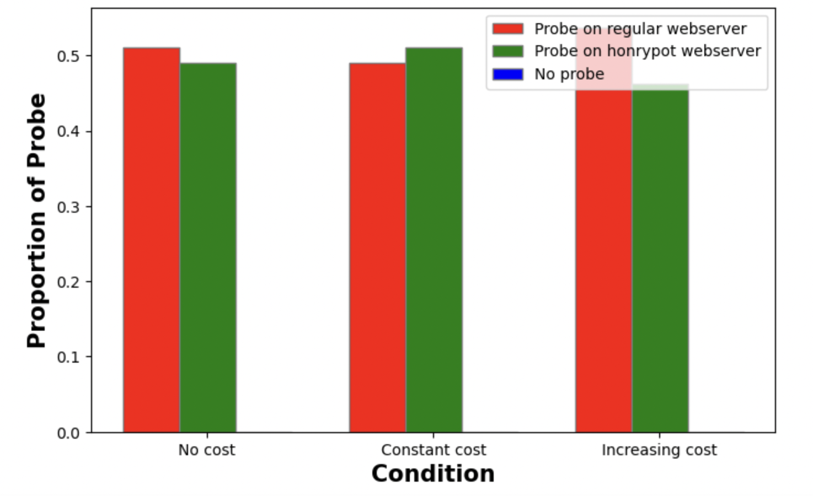



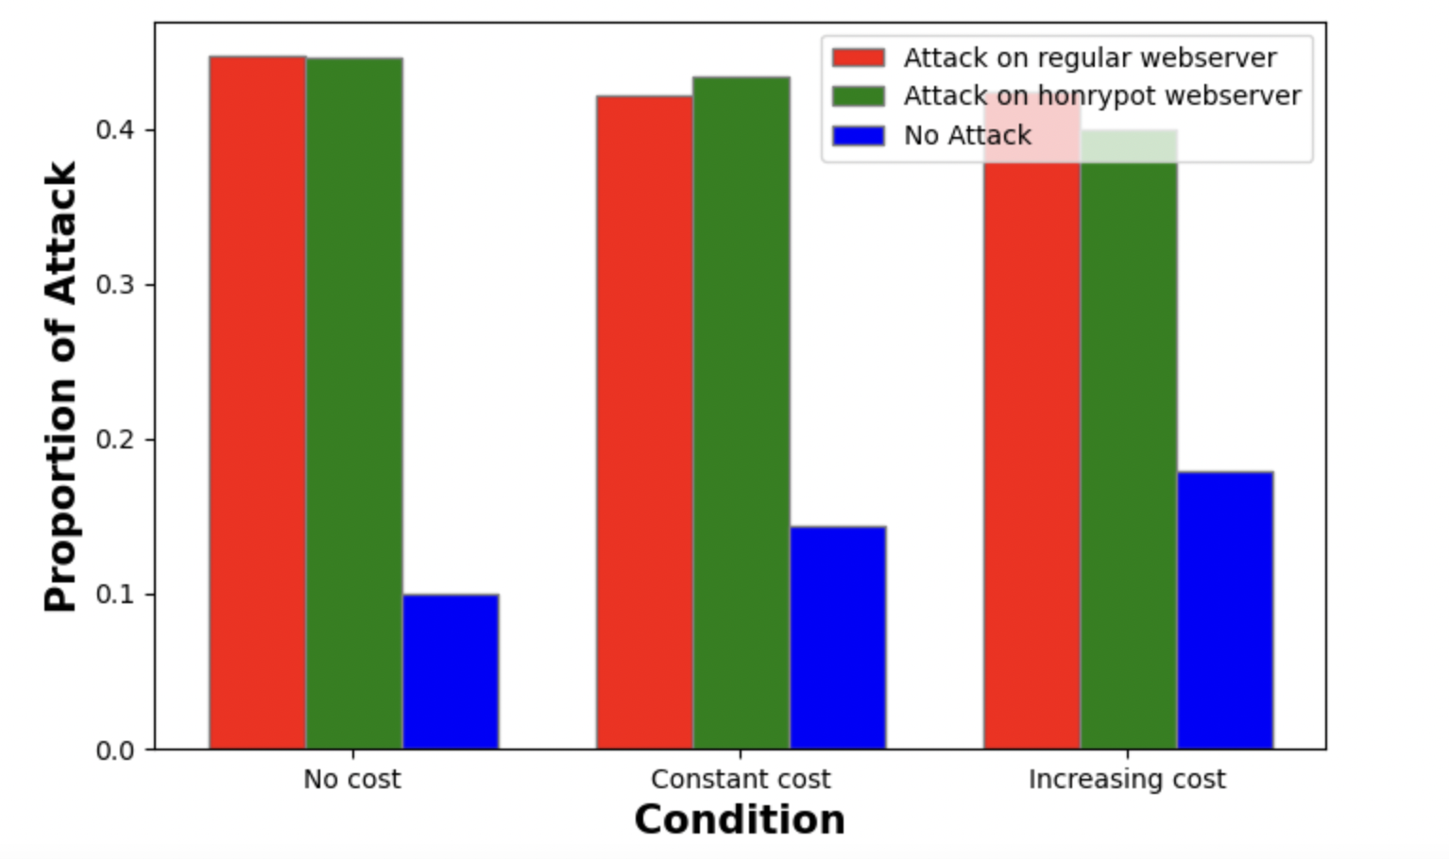



1. **Compare with previous work**

We also compare our finding with human data. In our modeling, we fixed the number of probing by 5, but in human data number of is not fixed. That’s why direct comparison with our model result and human data result is not possible. Therefore, we are trying to follow common patterns. Figure 9 and 10 compares our finding with human data. In probe stage(figure 9), we see both our model and human data follows same pattern, only in human data no values for no probe conditions. In attack stage(figure 10), different probing costs do not have significant impact on attack decision in both modeling and human data, also here no attack follows increasing trend in both cases.

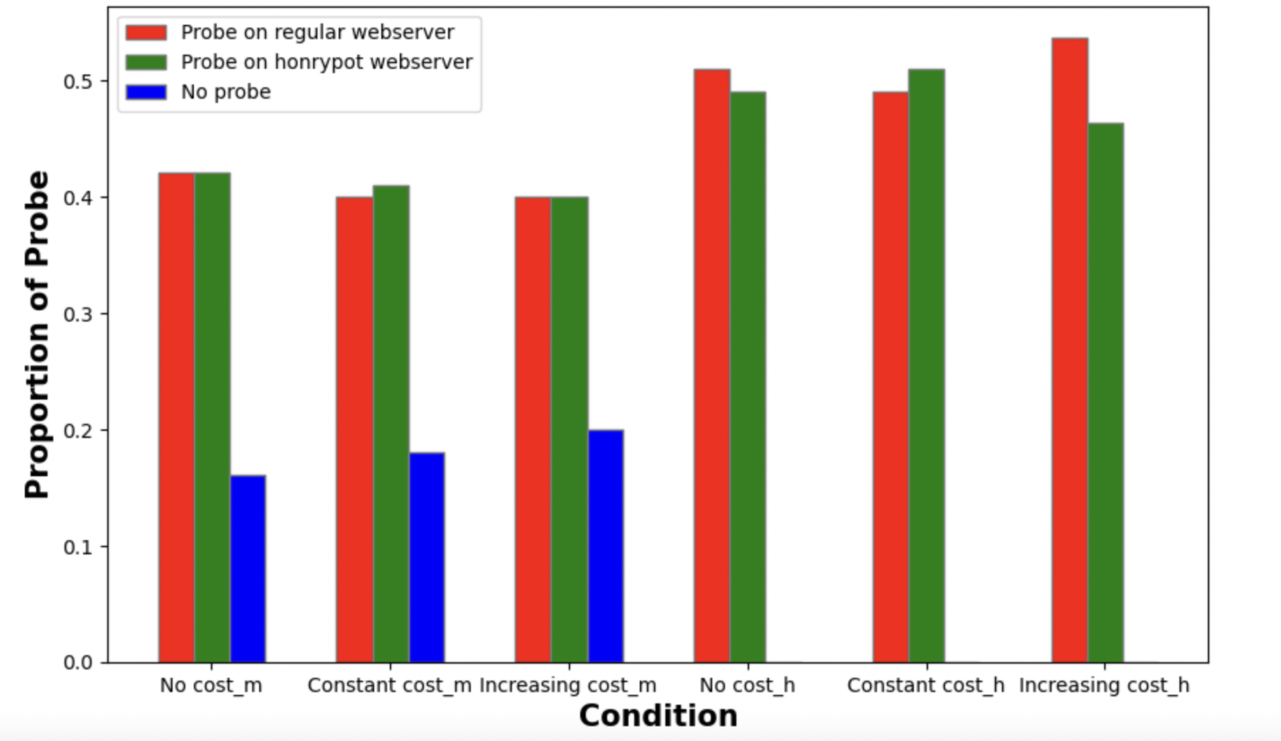



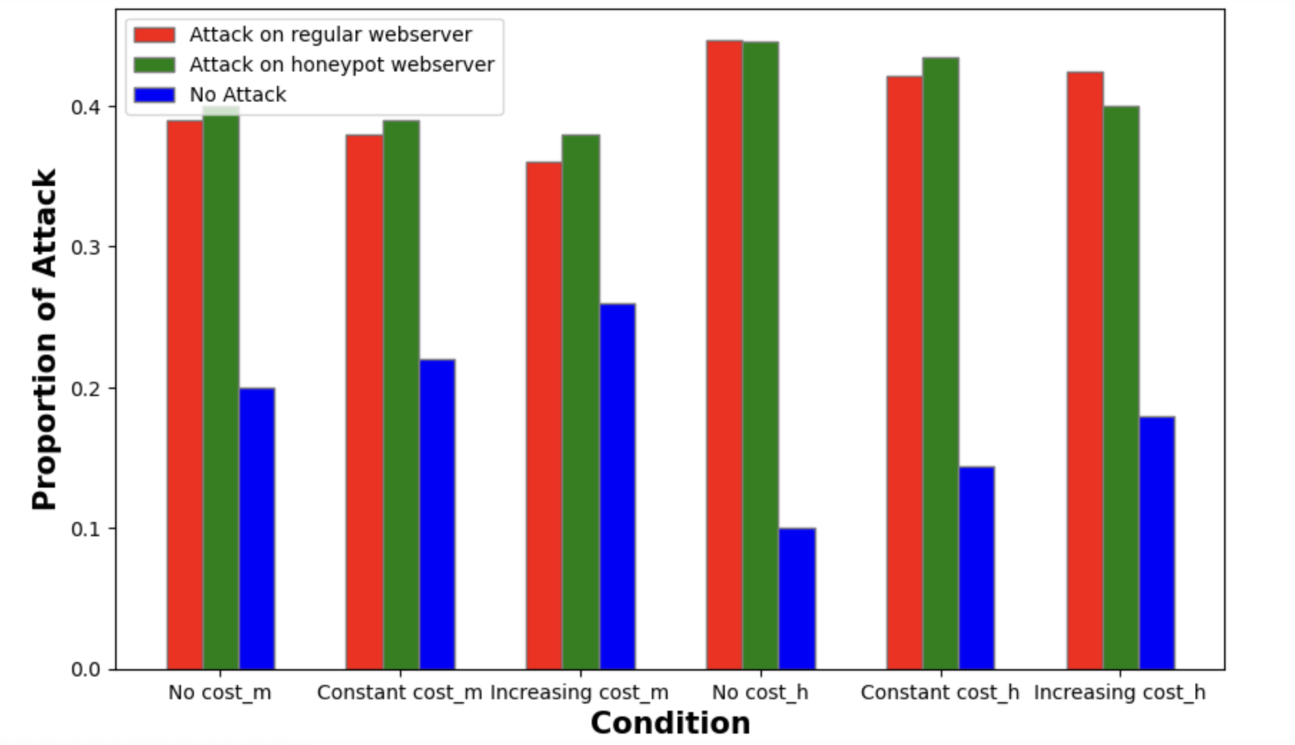



**V. CONCLUSION**

Using honeypots as a deception technique has demonstrated it’s vitality as a tactic for thwarting current cyberattacks. Non-canonical games have been designed and utilized by researchers in the field of adversarial cybersecurity to investigate the efficacy of deception in various cybersecurity scenarios. People have also looked into the numerous human aspects that influence the attacker's judgment in deception-based games.

Researchers have previously investigated the influence of network size on adversarial decisions in a deception game [1]. Moreover, Aggarwal et al. have worked on the influence of probing action costs on adversarial decision-making in such games. This work involves lab-based experiment to understand the impact of probing action costs on adversarial decisions. However, there is a lack of work regarding the IBL modeling of the attacker decision-making in a deception game. In our work, we have addressed this issue and developed an IBL model which helps us to better understand the attacker actions in cybersecurity situations. Our results demonstrate certain significant implications for real-world cyber attacks scenarios. If we consider different conditions like no cost, constant cost and increasing cost it is quite conspicuous that the attack-decision is identical in those situations. Hence, it can be said that probing action cost has no impact on adversary-decsions. In other words, making probes on the network expensive to attackers might not influence their attack decisions which conforms with the previous work [Aggarwal et al.].

Since there is a usage of real-world cyberattack variables in DG, where the attacker (or the model) first investigates the state of the webservers before launching an assault, some of the findings from our experiment could be applicable in the real-life situations. In the future, we intend to work on the sequential decisions from sampling in a cyber-attack scenario [2].

References

[1] Katakwar, Harsh, Palvi Aggarwal, Zahid Maqbool, and Varun Dutt. "Influence of probing action costs on adversarial decision-making in a deception game." In *ICT Analysis and Applications*, pp. 649-658. Springer, Singapore, 2022.

[2] Gonzalez, Cleotilde, and Palvi Aggarwal. "Sequential Decisions from Sampling: Inductive Generation of Stopping Decisions Using Instance-Based Learning Theory." (2021).